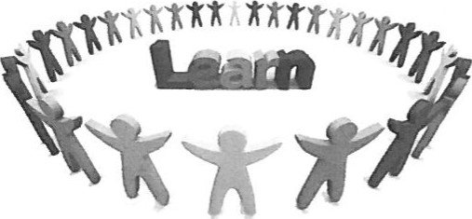Learning Style Preferences

HR 228

## Kolb's Learning Style Inventory

Adapted from: Hay Group Transforming Learning (2007). *Kolb Learning Style Inventory*

“We all learn in different ways. The Kolb Learning Style Inventory (LSI) is designed to help you understand how you learn best in educational settings and everyday life.” Haygroup, 2007

Instructions:

l. On the next page are 12 sentences with a choice of four endings. Rank the endings for each sentence according to how well you think each one fits with how you would go about learning something. Try to recall some recent situations where you had to learn something new.

1. Using the spaces provided, rank order each sentence ending - starting with a "4" for the sentence that **best** describes how you learn, down to a "l " for the sentence ending that seems the **least** like the way you would learn. Be sure to rank all of the endings for each sentence. No two endings in a set can be given the same ranking:

4 = MOST like you

1 = LEAST like you

1. In ranking the statements use your first impression. There are not right or wrong answers. The real you is best revealed through a first impression. Analyzing each group will obscure the real you. Do not answer as you WISH you were or as you think you SHOULD be, just answer as you honestly think you are.
2. Continue to rank all 12 sentences one at a time.
3. The ranking should take no more than FIVE minutes.
4. Once you have completed the sentences, add the numbers in each box down each column. Put that total in the box in the 'Total Score' row.
5. Check that the combined total scores equal 120. If they do not, recheck your scoring.

SENTENCES

|  |  |  |  |  |
| --- | --- | --- | --- | --- |
| 1. When I learn... | I like to deal with my feelings    1 | I like to watch and listen    4 | I like to think about ideas    3 | I like to be doing things.    1 |
| 2. I learn best when... | I trust my hunches and feelings    1 | I listen and watch carefully    4 | I rely on logical thinking    3 | I work hard to get things done    1 |
| 3. When 1 am learning... | I have strong feelings and reactions    4 | I am quiet and reserved.    2 | I tend to reason things out    3 | I am responsible about things    3 |
| 4. I learn by... | feeling    2 | watching    4 | thinking    1 | doing    4 |
| 5. When I learn... | I am open to new experiences    4 | I look at all sides of an issue    3 | I like to analyze things, break them into their parts    2 | I like to try things out    4 |
| 6. When 1 am learning... | I am an intuitive person    2 | I am an observant person    3 | I am a logical person    4 | I am an active person    2 |
| 7. I learn best from… | personal relationships    2 | observation    3 | rational theories    3 | a chance to try and practice    2 |
| 8. When 1 learn... | I feel personally involved in things    2 | I take my time before acting    1 | I like ideas and theories    3 | I like to see results from my work    2 |
| 9. I learn best when... | I rely on my feelings    2 | I rely on my observations    1 | I rely on my ideas    4 | I can try things out for myself    4 |
| 10. When I am learning... | I am an accepting person    2 | I am a reserved person    4 | I am a rational person    1 | I am a responsible person    2 |
| 11. When I learn ... | I get involved    2 | I like to observe  3 | I evaluate things    3 | I like to be active    4 |
| 12. I learn best when... | I am receptive and open-minded    2 | I am careful    2 | I analyze ideas    3 | I am practiœl    4 |
| Total Score | 26 | 34 | 33 | 33 |

**Graphing the Learning Style Grid on next page**

1. On the vertical axis pointing toward 12 0'clock (Concrete Experience - CE) place a large dot by the number which corresponds to your total score in column 1.
2. On the horizontal axis pointing toward 3 0'clock (Reflective Observation - RO) place a large dot by the number which corresponds to your total score in column 2.
3. On the vertical axis pointing toward 6 0'clock (Abstract Conceptualization - AC) place a large dot by the number which corresponds to your total score in column 3.
4. On the horizontal axis pointing toward 9 0'clock (Active Experimentation - AE) place a large dot by the number which corresponds to your total score in column 4.
5. Join the four dots to form a four-sided figure. Your scores indicate how much you rely on each of the four different learning modes: Concrete Experience, Reflective observation, Abstract Conceptualization, and Active Experimentation.

These learning modes make up a four phase learning cycle. Different learners start at different places in this cycle. **Effective learning eventually involves all four phases**. You can see by the placement of your dots which of the four learning phases you tend to prefer in a learning situation.

LEARNING STYLE GRID

CONCRETE EXPERIENCE (CE)

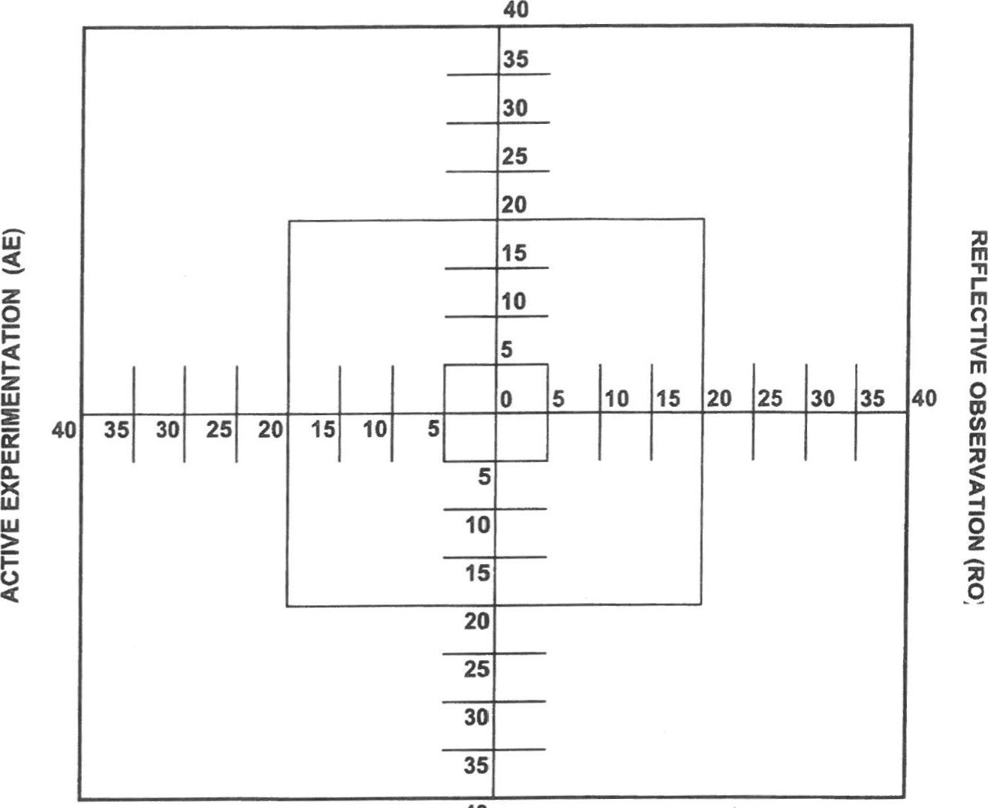

40

ABSTRACT CONCEPTUALISATION (AC)

